My Sports Kit
GENERAL:
- Sports Bag
- Helmet
- Towel
- Rain Parka
- Personal Items -Toilet/Meds
- Extra Shirt
- Sweatshirt/Jacket
- Water Bottle
- Spending Money
- Brimmed Hat
- Sun Screen
- Band-Aids
- Pen / Paper

Athletics
Track/Field
- Tire Glue/Tire Tools
- Spare (1)Front/ (2)Rear Tires
- Spare Set of Push Rims
- Athletic Tape
- Safety Pins
- Tire Pump/ Adapters
- Track Gloves/ Spares
- Push Rim Tacky
- Hand Warmers - Fall/Winter

Swimming:
- 2 Towels
- Tee Shirt
- Light Jacket

Sport | Age | Functional Class
TRACK
FIELD
SWIMMING
ARCHERY
WEIGHTLIFT
TABLE TENNIS
Functional Class Breakdown
Age
U11, U14, U16, U18, U20, U23, Adult, Master 35, M50, M60; Age as of 12/31/2014
Functional Class
(F)ield: (F)11-57; (TT)able Tennis 1-10
(S-SB-SM)wimming: 1-10, 11-13Blind , 14Cognitive
(A)rchery 1-3; (B)occi
(T)rack
Spinal Cord: (T)51-54WC
Spinal Cord: (F)51-57 WC
Cerebral Palsy:(T)32-34 WC; (T)35-38 standing
Blind:(T)11-13; Dwarf (T)40-41
Amputee / LesAutres :(T)42-47


2017
Athlete
Survival KIt

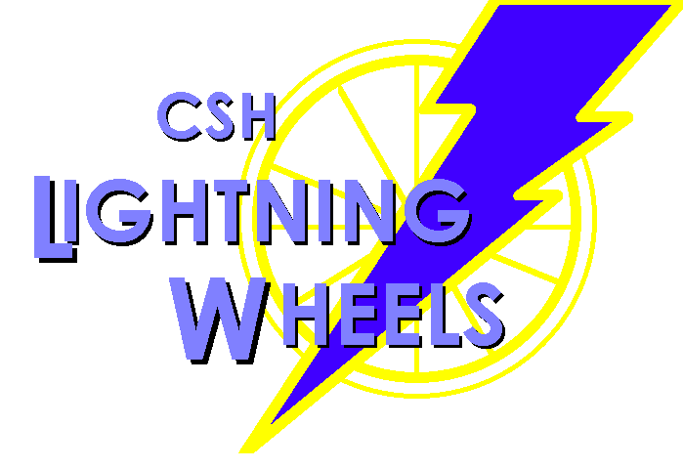

Children’s Specialized Hospital
Mountainside, Toms River,
New Brunswick, NJ
Coaches:
Trish Yurochko (908) 301-5424
Phil Galli - Paul Kolterjahn
Anne Marie Santos - Elke Van Hooydonk

Setting Goals:
Event | Detail | Prsnl Best | Goal | NR
40
60
100
200
400
800
1500
5000
Slalom
Free
Back
Breast
Fly
IM
Club
Softball
Discus
Shotput
Javelin

Results:
Wind/  New | CSH | Tri-State | Mason | Nationals

Why Keep Score
The CSH Lightning Wheel Program is designed to develop athletes in a fun environment. Whether a national champion or a great competitor the program instills the life skills of
setting goals and recognizing success.
If you don’t know
where you’re going
How do you know
when you’ve arrived!
Hitting the Road:
Event | PB  Goal | Date/  Time | Date/  Time | Date/  Time
1M
5K
5M
10K
15K
10M
PB = Personal Best

Go Lightning Wheels!!!!

