- Roll Call/Board Attendees: Debbie Armento, Ralph Armento, Ken Brucato, Jimmy Cuevas, Phil Galli, Jennifer Johnson, Daniel Martin, and Trisha Yurochko

Excused: Carolynne Bethka, Pat Redden
Guests: Gilberto and Amy Perez, Paul Kolterjahn, Richard Xue

Meeting was called to order at 10:00 AM. Ken asked for a moment of silence for Sidney Chew who had recently passed.

- Review/Approval of Last Meeting’s Minutes. Trisha made a motion to accept the minutes of January 22, 2011. Debbie seconded. Motion passed unanimously.

- Treasurer’s Report: There is a current total of $3,822.30 in the Tri-State account. Trisha reiterated that without proof of non-profit status, we are being charged a $30/month bank service fee. Ken stated that if we went with TD Bank, we would not be charged a monthly maintenece fee. It was decided to go with TD Bank. Currently Debbie is the second signer; however Phil stated that it should be an officer. It was decided that Danny Martin, vice –chair , would be the cosigner on the new account.

- Chairperson’s Report – No report.

- Old Business

- Tri-State Upcoming Meets

- Tri-State Swim Meet: Trisha reported that the meet was a success. There were a total of 27 swimmers; however, there were no adults.

- Newington Invitational (April 16):

- Children’s Specialized Hospital Invitational (May 7): Since Westfield HS is not available, this meet is going to take place at Rahway River Park. It is a 6 lane track for the 100s, 4 lanes on the curve. At this point, it appear s that athletes will have to be dropped off, since there is no parking there.

- Tri-State Wheelchair Meet (May 20-May 22): The track & field meet will take place @ Jersey City. We have a track survey and the application has been put in for IPC approval. We need to have a military presence in order to be eligible for a grant from USP. Phil is approaching two individuals; Ryan Chesterman and someone from a vet rehab center in Long Island. It is hopeful that we will be able to have a lot more adults than in the past.

- Junior Masonic Regional Meet (June 4, 5): This will again take place in South Brunswick. Although Debbie and Ralph are looking for another local pool, it may again have to be North Brunswick.

- Burke Wheelchair Games: Toni Boelsen has resigned as the Director of Community Programs. It is unclear who is going to take the lead; however the Games are tentatively scheduled for September 24.

- Background Checks
Ralph reminded all that it is time to do the yearly background checks for coaches and individuals who work directly with the youth. It was noted that the process of notification may in itself lend us to the possibility of a lawsuit. It was discussed that we should look towards perhaps putting a page on our website, stating the names of Tri-State registered coaches.

- NJDC: Debbie advised that the processs of getting the LOC on board has been very time-consuming. The LOC has been unresponsive at times. Trisha is helping Debbie with the task of tweaking the registration form. It looks as though there will not be an online registration this year. Their IT person has agreed, however, to help us out next year with the online forms.

- Tri-State Reunion: It was discussed that the most logical place might be Burke; especially since it is centrally located in the Tri-State region and is tied to a meet. Ralph will approach the Burke Wheelchair Games Committee to see if they have any interest in helping us out on this. The reunion would consist of a small reception following the Games.

- New Business

1 Elections.. The following BOD seats were subject to re-election:

Debbie Armento
Jimmy Cuevas
Trisha Yurochko
Terry Tierney – seat vacated

Debbie, Jimmy and Trisha previously consented to run for re-election. Richard Xue had previously sent in his intent to run. Gilberto Perez, attending the meeting, had stated from the floor as to his desire to run for a position. All were nominated and approved by the board.

Debbie, Jimmy and Trisha were re-elected to BOD positions; Gilberto was elected to the seat vacated by Terry Tierney. The election was monitored by the vice-chair.

It was then stated that in keeping with our bylaws, the Vice-Chairman and Treasurer have their officer seats up for reelection in June. A subsequent election will be held at that time for their seats.

2. Technology Issues

The state of social networking was discussed at length. It was generally agreed that Tri-State should increase our presence on the web with a facebook/twitter page. Richard Xue, present at the meeting, stated that he could definitely help us out in utilizing technology for this purpose. The Board unanimously agreed to have him take a crack at helping us in this regard.

Phil motioned to adjourn the formal meeting, Debbie seconded. The meeting was adjourned at 1:25 PM.
Respectfully submitted,
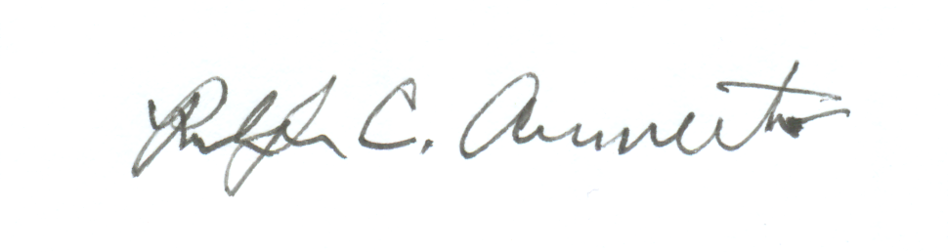
Ralph C, Armento
Secretary

