MINUTES OF THE BOARD OF DIRECTORS
TRI-STATE WHEELCHAIR ATHLETIC ASSOCIATION
@BURKE REHABILITATION HOSPITAL

SATURDAY, FEBRUARY 11, 2012 AT 9:30 AM

Meeting called to order at 9:30 am sharp.

Attendees: Debbie Armento, Ralph Armento, Carolynn Bethka, Ken Brucato, Jimmy Cuevas, Phil Galli, Jennifer Johnson, Pat Redden, Trisha Yurochko and “Dude.”

Excused: Kelly Bucchere, Shaun Bucchere, Danny Martin

The chairperson addressed the board and stated that as a result of the meet details, some of the items may have to be tabled to our next meeting.

Review and Approval of Minutes: Trisha made a motion to approve the minutes, Phil seconded. Motion passed unanimously.

Treasurer’s Report: Trisha stated that there was little activity from the last phone conference meeting in January. JFK paid their equipment usage fee from last year’s games; the Masons have yet to pay theirs. Ralph made a motion to accept the report, Jimmy seconded. Motion carried unanimously.

Tri-State Meet Status:

- Tri-State Games (May 18-20, 2012). Lincoln Park in Jersey City will again be the venue for the Games. The 5K road race will be at Liberty State Park and we are in the process of securing the dog park (baseball fields) for the archery competition. Tom McCann sent Ralph a conditional approval. Ralph has contacted Tina Kaufman-Cain to prepare the IPC sanctioning paperwork. Ralph and Jimmy plan to meet with Tom in the near future to go over logistics. We are considering using St. Peter’s College for the table tennis and powerlifting events. Trisha and Pat are working on a site visit to the facility.

Debbie and Trisha will continue to work with Tatiana on the registration packet.

Phil advised the board that we again will be receiving a grant from the USOC (through USP). It could be a sizeable grant; however there are aggressive targets that USP will be mandating. We really have to make a concerted effort to bring in 15-20 participants from the military. Phil and Jimmy will be approaching their contacts in order to get more wounded warrior participation.

The group discussed this at length and the following assignments/contacts were given out as follows:

Ralph | PVA News (S ‘n S), Pallaestra
Jimmy | John Hamre, United Spinal, Action!
Carolynne | Able, Spina Bifida Assoc., Bronx VA Hospital, Helen Hayes
Phil | Ryan Chesterman & Ed Richards

In addition to the Tri-State competition, it was agreed to that we should be running clinics for the military in order to arouse their interest. Field, archery, powerlifting and table tennis clinics were discussed. We plan to come up with a “save the date” flyer that will be distributed, especially to the aforementioned contacts.

Attention was then turned to some of the details needed for the meet. Ken stated that he would be responsible for getting a quote for a tent (20x20).. Renting portable bathrooms was discussed. It was decided that we may need at least 3; two for the area around the track, and one at the archery site. We will approach Tom to determine who he uses. It was discussed that some of the Navigators team/parents might be able to volunteer to help with the food. Another “Picnic in the Park” was agreed upon, now that we are moving towards getting a big enough tent. We are going to ask Gil if he would be able to DJ during the picnic festivities. With regard to generators, we had a problem last year with only having one generator. There needs to be a generator at all times on the track.

- Junior Masonic Meet. Ralph and Ken met with the two heads of the Masonic committee; Drew Jardine and Neal McCarthy. It was clear that they did not want to travel to differen venues; they communicated that they were interested in either the Morristown Beard Academy or in North Brunswick High School.. It has to be the first weekend of June, as the DeMolay convention is on the second weekend. If we scheduled it at South Brunswick (the only weekend SBHS has available), there would be no Masonic officers present. We will be exploring both venues, with perhaps using the Cranford complex as a backup.

- Other Meets (non-sanctioned)

- Newington Meet ( Don Chaffee) – March 24
- Children’s Meet – May 5
- Burke Wheelchair Games – September 29

Tri-State Reunion – No report – tabled

Policy and Procedures Manual – Ralph and Trisha will be working on it. There was a question regarding monetary limits for one vs. two signatures. It was motioned by Phil that for expenses less than $500, there should be only one signature needed. Debbie seconded. It was passed 9-0 with one abstention.

Tri-State Annual Meeting: Ken publicly apologized to Danny for the misunderstanding that ensued over the “appropriateness” of the meeting facility. It was agreed that we should hold it at the Jersey City Municipal Utilities Authority on March 17. Ken stated that he would make up the agenda and circulate it for ideas/approval.

RPO/RSO Proposal: Ralph advised that the RSO Council has yet to issue further guidelines on the proposal, but would be meeting later in the month. This discussion was tabled.

By- Laws: The BOD then approached the task of reviewing the proposed by-Laws changes; the result of which will be posted on the web prior to the Annual Meeting.

Ralph announced that as a result of a possible conflict of interests, he would not be running for another term as the Secretary; however would remain on the Board until his term has expired.

The voting protocol was then discussed. As a result of the difficulty in holding spring BOD meetings, the board will vote on the officers following the general member-at-large election at the Annual Meeting.

Phil motioned to adjourn the meeting, Trisha seconded. Meeting adjourned at 12:50 PM

Next meeting will be our Annual Membership Meeting on Saturday March 17 at the JCMUA.

Respectfully submitted,

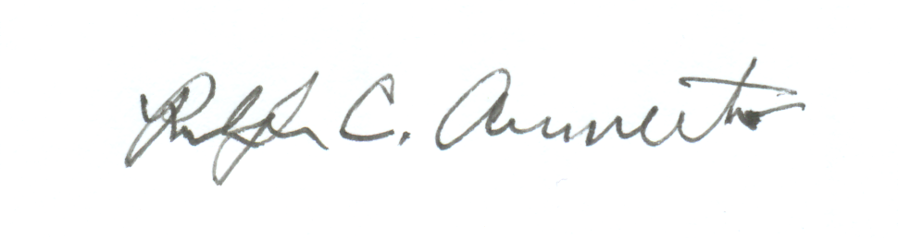

Ralph C. Armento
Secretary

